Large Language Model
An LLM is trained mainly on text data to understand, generate, and reason using language.
🔹 What LLMs can do
- Write essays, emails, code
- Answer questions
- Summarize documents
- Translate languages
- Reason step-by-step
Example: Text → LLM → Text
What is a Vision Model?
A Vision Model is trained to understand images or videos instead of text.
🔹 What Vision Models can do
- Identify objects & faces
- Read text from images (OCR)
- Detect defects
- Segment images
- Analyze medical & satellite images
Example: Image / Video → Vision Model → Labels / Boxes / Masks
What is Multimodal Models (Vision + LLM)?
Modern systems combine vision + language, allowing models to see and talk.
Example: Text + Image → Multimodal Model → Text / Reasoning

Real Use cases:

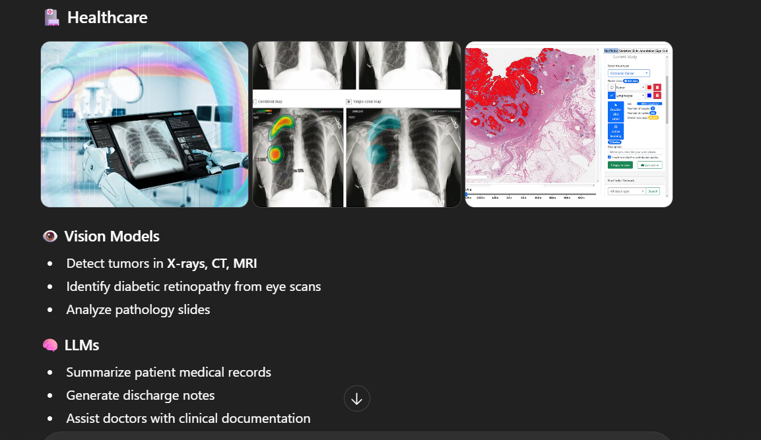
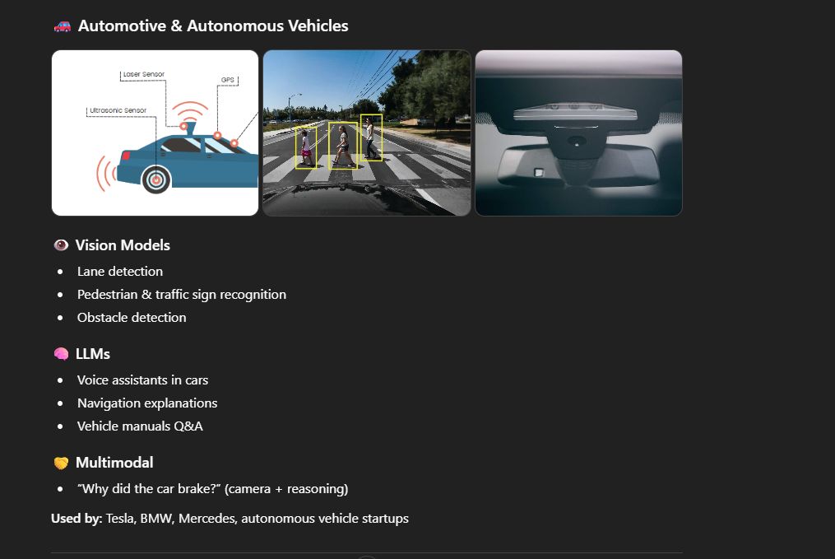
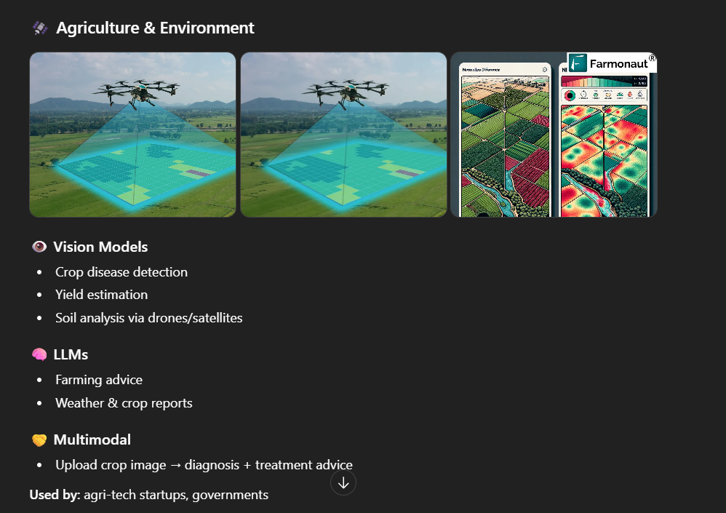

Vision models from different service provides:
Vision (image-understanding & multimodal) models from major service providers, grouped by company:

Company | Vision Capable Model | Capability | Best For
Open AI | GPT 4.0, 4.1 & GPT Vision | * Image understanding + text + audio  * OCR, charts, diagrams, medical-style images (non-diagnostic)  * Image → reasoning → text/code | General-purpose vision + reasoning, assistants, education, enterprise apps
Google | Gemini 1.5 Pro, Gemini 1.5 Flash & Vision Transformer (ViT) | * Strong image + video understanding  * Long-context multimodal reasoning  * Document & diagram analysis | video analysis, documents, large-scale Google Cloud apps
Meta | LLaVA, SAM and DINOv2 | * Image segmentation (SAM)  * Visual question answering  * Research-friendly & open-weigh | Computer vision research, custom training, academia
Amazon AWS | Amazon Recognition and  Titan Multimodal | * Face recognition, object detection  * Video moderation & surveillance use-cases | Security, compliance, retail, AWS pipelines
Anthropic | Claude 3.5 | * Image + document understanding  * Strong reasoning over screenshots & PDFs | Document review, compliance, legal & business analysis

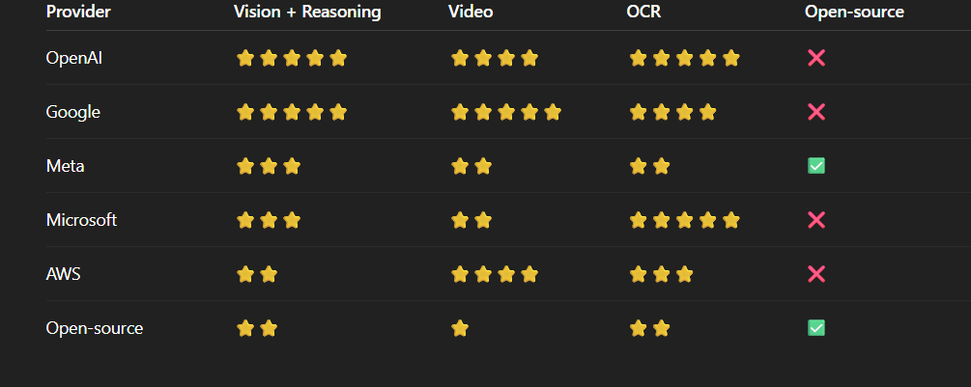
Check the cutoff date for Chatgpt, Qwen and Deepseek ?
- Deepseek -> Cutoff date is July 2024 (My training data includes a vast amount of text, code, and various types of information up to July 2024.)
- Qwen3 (Max) -> Cutoff date is June 2024 (My training data includes a vast amount of text, code, and various types of information up to June 2024.)
- ChatGPT 5.2 -> Cutoff date is June 2024 (My training data includes a vast amount of text, code, and various types of information up to June 2024.)
Search for a Testscript or testcases with Thinking and normal model in chatgpt,Qwen and deepseek (any domain or your office app) ?
Salesforce Login: Generate a test case for Login page of Salesforce application?
- ChatGPT 5.2 - >
Functional Testcases: -
TC ID | Test Scenario | Test Steps | Test Data | Expected Result
TC_LG_01 | Login with valid credentials | Open login page → Enter username → Enter password → Click Login | Valid username & password | User is successfully logged in and redirected to Home/Dashboard
TC_LG_02 | Login with valid username & invalid password | Enter valid username → Enter wrong password → Click Login | Valid username, invalid password | Error message displayed
TC_LG_03 | Login with invalid username & valid password | Enter wrong username → Enter valid password → Click Login | Invalid username | Error message displayed
TC_LG_04 | Login with invalid username & invalid password | Enter invalid username & password → Click Login | Invalid data | Error message displayed
TC_LG_05 | Login with empty username | Leave username blank → Enter password → Click Login | Blank username | Username required message
TC_LG_06 | Login with empty password | Enter username → Leave password blank → Click Login | Blank password | Password required message
TC_LG_07 | Login with both fields empty | Leave both fields blank → Click Login | Blank | Validation messages shown
TC_LG_08 | Login using Enter key | Enter valid credentials → Press Enter | Valid credentials | User logged in successfully

Negative Test Cases:
TC ID | Test Scenario | Steps | Expected Result
TC_LG_09 | Password case sensitivity | Enter correct username & wrong-case password | Login fails
TC_LG_10 | Username case sensitivity | Enter username in different case | Login behavior as per Salesforce rules
TC_LG_11 | Leading/trailing spaces in username | Enter spaces before/after username | Spaces ignored or error shown
TC_LG_12 | Leading/trailing spaces in password | Enter spaces in password | Login fails
TC_LG_13 | Special characters in username | Enter special characters | Validation error
Security Test Cases:
TC ID | Test Scenario | Steps | Expected Result
TC_LG_14 | Masked password field | Type password | Password characters are masked
TC_LG_15 | SQL Injection | Enter ' OR 1=1 -- in fields | Login blocked
TC_LG_16 | Brute force attack | Try multiple wrong passwords | Account locked after max attempts
TC_LG_17 | Session timeout | Login → Stay idle | User logged out after timeout
TC_LG_18 | Direct URL access without login | Access internal URL directly | Redirected to login page
TC_LG_19 | Browser back after logout | Login → Logout → Press back | User not logged in
UI / UX Test Cases:
TC ID | Test Scenario | Expected Result
TC_LG_20 | Page loads correctly | Login page loads without errors
TC_LG_21 | Logo visibility | Salesforce logo displayed properly
TC_LG_22 | Field labels clarity | Username & Password labels visible
TC_LG_23 | Error message clarity | Clear, user-friendly error messages
TC_LG_24 | Tab navigation | Cursor moves logically using Tab
TC_LG_25 | Show/Hide password (if enabled) | Password visibility toggles correctly

2. Qwen3 Max -
Test Case ID: TC_SF_LOGIN_01
Test Case Title: Verify successful user login to Salesforce with valid credentials
Preconditions:
- The user has a valid Salesforce account with an active username and password.
- The user has internet connectivity.
- The Salesforce login page is accessible at https://login.salesforce.com.
Test Steps:
- Navigate to the Salesforce login URL: https://login.salesforce.com.
- Enter a valid username in the "Username" field.
- Enter the corresponding valid password in the "Password" field.
- Click the “Log In” button.
Expected Results:
- The user is successfully redirected to their Salesforce Home page (or default landing page).
- The page title should include “Salesforce” or the user’s organization name.
- The user’s name or profile icon should be visible in the top-right corner, confirming authentication.
Postconditions:
- User remains logged in unless explicitly logged out.
- Session cookie is set correctly.
Test Data:
- Username: testuser@example.com
Test Case ID: TC_SF_LOGIN_02
Title: Verify error message for invalid username or password
Preconditions:
- User is on the Salesforce login page (https://login.salesforce.com).
Test Steps:
- Enter an invalid username (e.g., wronguser@example.com).
- Enter an invalid password (e.g., WrongPass!).
- Click “Log In”.
Expected Result:
- Error message displayed: “Please check your username and password. If you still can't log in, contact your Salesforce administrator.”
- User remains on the login page.

Test Case ID: TC_SF_LOGIN_03
Title: Verify validation for empty username and password fields
Preconditions:
- User is on the Salesforce login page.
Test Steps:
- Leave Username field blank.
- Leave Password field blank.
- Click “Log In”.
Expected Result:
- System displays inline validation errors:
  - “Please enter your username”
  - “Please enter your password”
- Login attempt is not submitted.
Test Case ID: TC_SF_LOGIN_04
Title: Verify “Forgot Your Password?” flow
Preconditions:
- User has a valid Salesforce account.
- User is on the login page.
Test Steps:
- Click the “Forgot Your Password?” link below the password field.
- Enter the registered email/username in the reset dialog.
- Click “Continue”.
Expected Result:
- Success message: “If the username matches an existing account, you’ll receive an email with instructions to reset your password.”
- User receives a password reset email (verify via email client or mock service in testing).
Test Case ID: TC_SF_LOGIN_05
Title: Verify Multi-Factor Authentication (MFA) prompt after valid credentials
Preconditions:
- User’s Salesforce org enforces MFA.
- User has enrolled in MFA (e.g., via Authenticator app or SMS).
Test Steps:
- Enter valid username and password.
- Click “Log In”.
Expected Result:
- User is redirected to the MFA verification screen.
- Options to approve via authenticator app, SMS, or security key are displayed.
- After successful MFA verification, user lands on the Salesforce Home page.
Use the tokenizer to calculate the tokens for different prompts (with space ,with special characters without space etc)
https://platform.openai.com/tokenizer

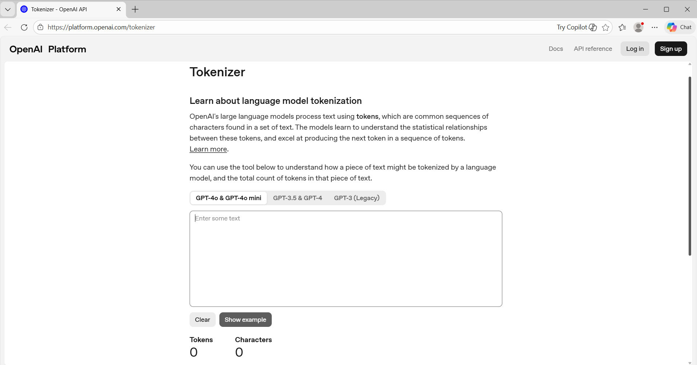

Prompt – Generate a test case for Login page of Salesforce application?

Generate a test case for Login page of Salesforce application?

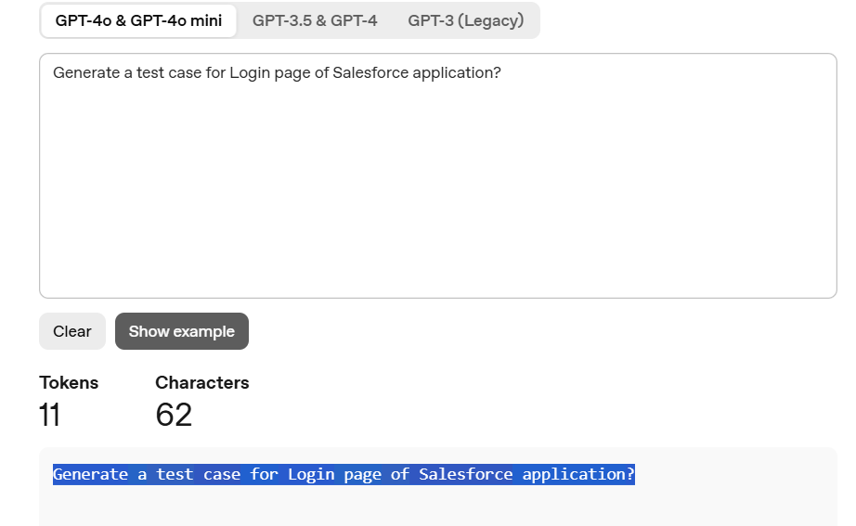
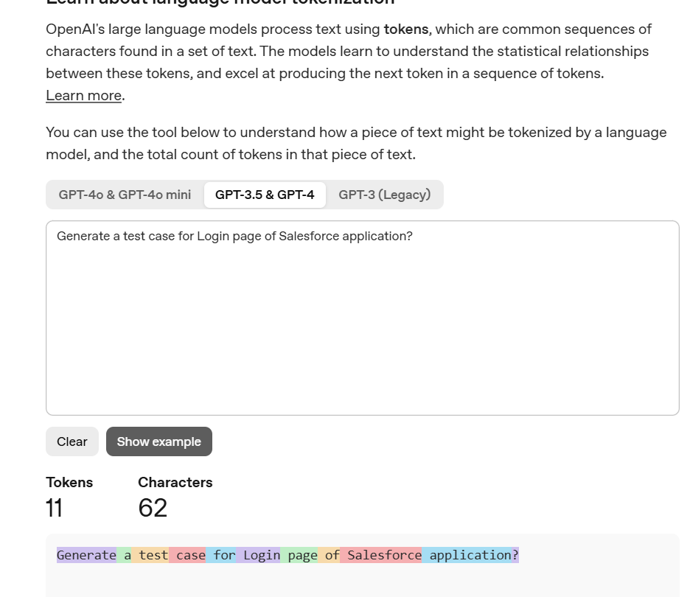
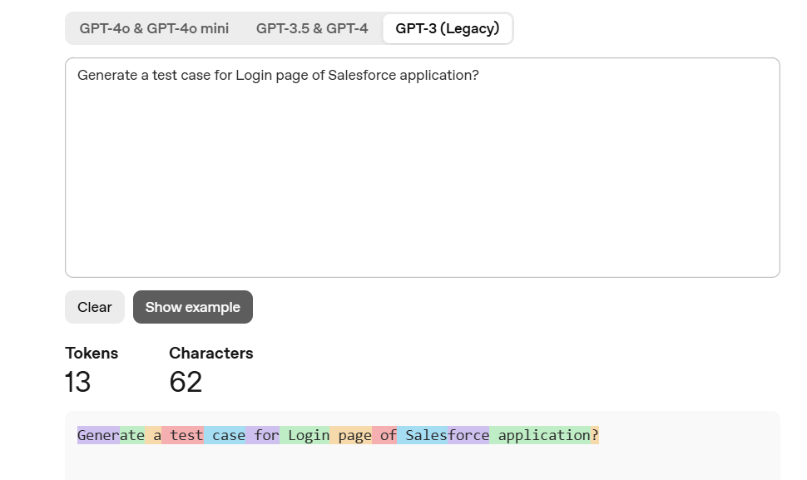

From Openrouter ai --Extract the values of
1)Context window
2)Input tokens(with price)
3)Output token (with price)

Link : https://openrouter.ai/models
